**MYSQL Practical**

Create below tables and also add required primaary key, foreign key and constraints in it.

- User,

- Product,

- Order (with User ID, Order status and expected delivery date)

- Order detail (order id, product Ids)

1. Fetch all the User order list and include atleast following details in that.

- Customer name

- Product names

- Order Date

- Expected delivery date (in days, i.e. within X days)

2. Create summary report which provide information about

- All undelivered Orders

- 5 Most recent orders

- Top 5 active users (Users having most number of orders)

- Inactive users (Users who hasn’t done any order)

- Top 5 Most purchased products

- Most expensive and most chepest orders.

* **Creating Database:**

CREATE DATABASE db_practical;

* **Using Database:**

USE db_practical;

* **Creating USER Table:**

CREATE TABLE user (

`userid` INT(11) PRIMARY KEY NOT NULL,

`name` VARCHAR(20) NOT NULL,

`contact` INT(10) NOT NULL,

`address` VARCHAR(50),

`gender` CHAR(2) NOT NULL,

`nationality` VARCHAR(50)

);

* **Adding Auto-increment to primary Key**

ALTER TABLE `db_practical`.`user`

CHANGE COLUMN `userid` `userid` INT NOT NULL AUTO_INCREMENT ,

ADD UNIQUE INDEX `userid_UNIQUE` (`userid` ASC) VISIBLE;

* **Inserting Data:**

INSERT INTO `user` (`name`,`contact`,`address`,`gender`,`nationality`) VALUES('Abhishek',1234567,'Mahidharpura Surat 395003','M','Indian') ;

INSERT INTO `user`(`name`,`contact`,`address`,

`gender`,`nationality`) VALUES('Kishan',567890,'Kutch','M','Indian'),

('Heema',152637,'Ahemadabad','F','Indian'),

('Sunny',938271,'Torento','M','Cannadian'),

('Chintan',834679,'Belgium','M','Europian');

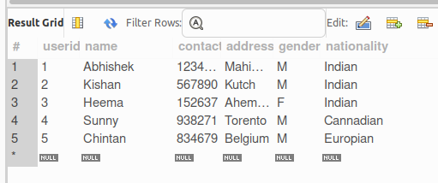

* **Creating PRODUCT Table:**

CREATE TABLE product (

`productid` INT PRIMARY KEY NOT NULL

AUTO_INCREMENT UNIQUE,

`product_name` VARCHAR(20) NOT NULL,

`manufacturerid` INT NOT NULL,

`price` FLOAT DEFAULT 0.0,

`quantity` INT DEFAULT 0,

`weight` FLOAT DEFAULT 0,

FOREIGN KEY (manufacturerid) REFERENCES user(userid)

ON UPDATE CASCADE

ON DELETE CASCADE

);

* **Inserting Data:**

INSERT INTO `product` (`product_name`,`manufacturerid`,`price`,`quantity`,

`weight`) VALUES('ONE PLUS Nord CE 2',4,26500.00,10,3.75);

INSERT INTO `product` (`product_name`,`manufacturerid`,`price`,`quantity`,

`weight`) VALUES('ONE PLUS Nord 3',4,20500.00,15,3.50),

('Samsung Smart TV',3,90499.00,25,20.50),

('Apple Air Pods',5,56450.55,30,2.10),

('Apple I-Phone 14',5,95463.55,15,4.10),

('Samsung Z-Fold',3,50000.00,6,3.57);

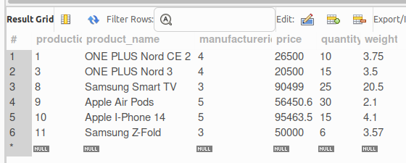

* **Creating ORDER Table:**

CREATE TABLE `order` (

`orderid` INT PRIMARY KEY NOT NULL

AUTO_INCREMENT UNIQUE,

`userid` INT NOT NULL,

`order_status` VARCHAR(25) DEFAULT "Pending",

`order_date` DATE NOT NULL,

`expected_delivery` DATE NOT NULL,

`quantity` INT DEFAULT 0,

FOREIGN KEY (userid) REFERENCES user(userid)

ON UPDATE CASCADE

ON DELETE CASCADE

);

* **Inserting Data:**

INSERT INTO `order`(`userid`,`order_status`,`order_date`,

`expected_delivery`,`quantity`) VALUES (1,'Accepted',

'2022-04-16','2022-04-17',1);

INSERT INTO `order`(`userid`,`order_status`,`order_date`,

`expected_delivery`,`quantity`)

VALUES (2,'Delivered','2023-01-16','2023-01-16',2),

(1,'Pending','2022-12-30','2023-01-01',1),

(2,'Declined','2022-12-25','2022-12-26',1),

(3,'Delivered','2023-01-30','2023-01-30',5),

(3,'Delivered','2023-01-30','2023-01-30',1);

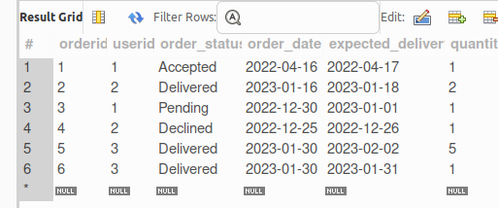

* **Creating ORDER_DETAILS Table:**

CREATE TABLE `order_details` (

`orderid` INT NOT NULL REFERENCES `order`(orderid)

ON UPDATE CASCADE

ON DELETE CASCADE,

`productid` INT NOT NULL REFERENCES `product`(productid)

ON UPDATE CASCADE

ON DELETE CASCADE,

`trans_status` VARCHAR(30) DEFAULT 'Pending',

`delivery_date` DATE);

* **Inserting Data:**

INSERT INTO `order_details` (`orderid`,`productid`,`trans_status`,`delivery_date`)

VALUES (1,1,"Done",NULL),

(2,1,"Done","2023-01-18"),

(5,3,"Done","2023-01-30"),

(6,4,"Done","2023-02-01"),

(3,3,"Pending",NULL);

INSERT INTO order_details(orderid,productid,trans_status) VALUES(4,9,"Done");

* **Adding Amount Column**

ALTER TABLE `db_practical`.`order_details`

ADD COLUMN `amount` BIGINT NULL DEFAULT 0 AFTER `delivery_date`;

* **Update amount column**

UPDATE order_details SET amount = (SELECT p.price*o.quantity FROM `order` o , `product` p WHERE o.orderid=1 AND p.productid=1) WHERE orderid = 1;

UPDATE order_details SET amount = (SELECT p.price*o.quantity FROM `order` o , `product` p WHERE o.orderid=2 AND p.productid=1) WHERE orderid = 2;

UPDATE order_details SET amount = (SELECT p.price*o.quantity FROM `order` o , `product` p WHERE o.orderid=5 AND p.productid=3) WHERE orderid = 5;

UPDATE order_details SET amount = (SELECT p.price*o.quantity FROM `order` o , `product` p WHERE o.orderid=6 AND p.productid=8) WHERE orderid = 6;

UPDATE order_details SET amount = (SELECT p.price*o.quantity FROM `order` o , `product` p WHERE o.orderid=3 AND p.productid=3) WHERE orderid = 3;

UPDATE order_details SET amount = (SELECT p.price*o.quantity FROM `order` o , `product` p WHERE o.orderid=4 AND p.productid=9) WHERE orderid = 4;

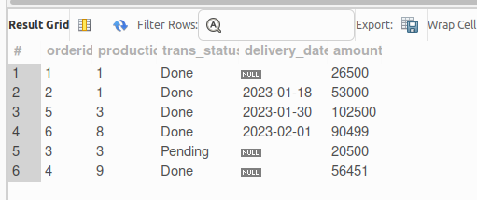

* **MySQL PRACTICAL QUERY:**

**1) Fetch all the User order list and include atleast following details in that.**

**- Customer name**

**- Product names**

**- Order Date**

**- Expected delivery date (in days, i.e. within X days)**

SELECT u.name AS "Customer Name", p.product_name AS "Product Name", o.order_date AS "Order Date",

CONCAT(DATEDIFF(o.expected_delivery,o.order_date)," days") AS "Expected Delivery"

FROM `order_details` od

LEFT JOIN `order` o USING(`orderid`)

LEFT JOIN `product` p USING(productid)

LEFT JOIN `user` u USING(userid)

WHERE delivery_date IS NOT NULL

ORDER BY o.order_date;

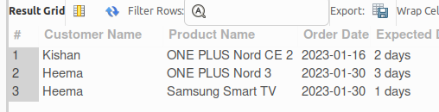

**2. Create summary report which provide information about**

**- All undelivered Orders**

SELECT * FROM `order` WHERE NOT order_status = "Delivered";

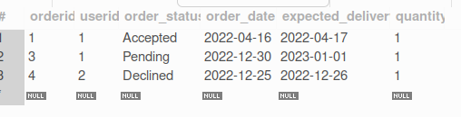

**- 5 Most recent orders**

SELECT * FROM `order` ORDER BY orderid DESC LIMIT 5;

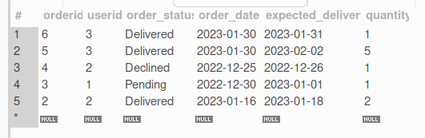

**- Top 5 active users (Users having most number of orders)**

**OPTION 1:**

SELECT u.name AS "Active Users", count(o.quantity)

AS "No. Of Orders"

FROM `order` o

INNER JOIN `user` u USING(userid)

GROUP BY u.name

ORDER BY count(o.quantity) DESC LIMIT 5;

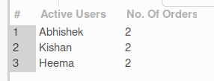

**- Inactive users (Users who hasn’t done any order)**

SELECT usr.name AS "Inactive Users" FROM `user` usr

WHERE usr.userid NOT IN (

SELECT DISTINCT o.userid

FROM `order` o INNER JOIN `user` u USING(userid)

);

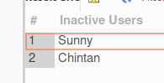

**- Top 5 Most purchased products**

SELECT p.product_name AS "Most Purchased Products", count(o.quantity) AS "Total Quantity"

FROM `order_details` od

INNER JOIN `product` p USING(productid)

INNER JOIN `order` o USING(orderid)

GROUP BY p.product_name

ORDER BY count(o.quantity) DESC LIMIT 5;

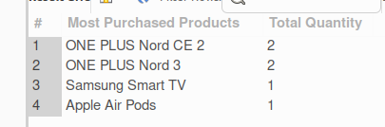

**- Most expensive and most chepest orders.**

SELECT max(output.total) AS "Most Expensive Order", min(output.total) AS "Most Chepest Order" FROM (

SELECT p.price*o.quantity AS total FROM `order_details` od

INNER JOIN `order` o USING(orderid)

INNER JOIN `product` p USING(productid)

) AS output;

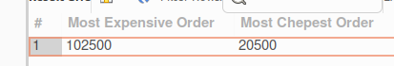

**OPTION 2:**

WITH main AS (SELECT p.product_name AS pname, p.price as price, o.quantity as quantity

FROM `order_details` od

INNER JOIN `order` o USING(orderid)

INNER JOIN `product` p USING(productid))

SELECT @total as "Total Amount", main.pname, "Most Chepest" AS "Order Status"

FROM main WHERE (@total:= main.price*main.quantity) = (

SELECT MIN(main.price*main.quantity) AS min

FROM main)

UNION

SELECT @total as "Total Amount", main.pname, "Most Expensive" AS "Order Status"

FROM main WHERE (@total:= main.price*main.quantity) = (

SELECT MAX(main.price*main.quantity) AS max

FROM main);

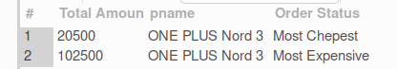

**OPTION 3:**

SELECT p.product_name as "Product", od.amount as "AMOUNT", "Most Expensive" AS "Status"

FROM `order_details` od INNER JOIN product p USING(productid) WHERE od.amount = (

SELECT MAX(odr.amount) FROM `order_details` odr)

UNION

SELECT p.product_name as "Product", od.amount as "AMOUNT", "Most Chepest" AS "Status"

FROM `order_details` od INNER JOIN product p USING(productid) WHERE od.amount = (

SELECT MIN(odr.amount) FROM `order_details` odr);

